

ELECTRONICS STORE

Using HTML, CSS, JavaScript





mENTOR - lavish ARORA SIR

sUBMITTED BY-

aarushi vashisht [2110990016]

Group – 5 , Year – 3rd

INDEX

|  |  |  |
| --- | --- | --- |
| S.No | Topic | Pageno |
| 1 | Introduction | 1 |
| 2 | Why I choose this project | 2 |
| 3 | Homepage overview | 3-7 |
| 4 | Category pages | 8-21 |
| 5 | About page | 22 |
| 6 | Contact page | 23-24 |
| 7 | Sign up page | 25-26 |
| 8 | Review page | 27 |
| 9 | Track your order page | 28 |
| 10 | Demo page | 29 |
| 11 | Help centre page | 30-31 |

**Introduction**

Welcome to the Electronic Store Project Showcase. In this report, I'm thrilled to present my web development project – an electronic store website designed to cater to the needs of tech-savvy customers. This project reflects my passion for e-commerce and electronics, which drove me to create a user-friendly and engaging online platform.

The Electronic Store website features various electronic products, from cutting-edge smartphones and accessories to top-tier laptops and high-definition televisions. Whether you're a gadget enthusiast or looking for the latest tech innovations, our website has something to offer everyone.

To ensure a seamless shopping experience, I've meticulously designed and integrated various pages within the website. You'll find a dynamic homepage that showcases featured products and deals, subcategory pages dedicated to televisions, mobile devices, and laptops, an order tracking feature for convenience, and a dedicated review section where our valued customers can provide feedback.

One exciting addition is the demonstration page, which lets you explore the website's features and functionality. I've created 30 pages for this project, all aimed at delivering a comprehensive and immersive online shopping experience.

**Why I Chose This Project**

I embarked on creating this electronic store website driven by my passion for e-commerce and electronics. The ever-evolving world of online shopping and technology has always fascinated me, and this project provided the perfect canvas to express my creative ideas. It also offered a valuable opportunity for personal growth and skill development. Through this project, I aimed to apply my knowledge of HTML, CSS, and JavaScript to a real-world application, turning my passion into a tangible web development project.

What motivated me even more was the opportunity to make online shopping more straightforward and enjoyable. As technology becomes a more significant part of our lives, having an easy and fun way to shop for electronics is essential. This project was like a puzzle where I had to combine different web technologies to create something user-friendly. It wasn't just about coding; it was about designing a website that people could easily use to explore and purchase their favourite electronic gadgets.

Furthermore, I was inspired by the prospect of providing a user-friendly and engaging online platform for customers to explore and shop for their favourite electronic products.

**Homepage overview**

The Electronic Store project introduces a dynamic homepage combining user-friendly navigation and a visually appealing design. This homepage serves as the central hub for customers to explore an extensive product catalogue featuring items from reputable companies. When a customer clicks on a product, a convenient pop-up notification informs them that the item has been successfully added to their cart, ensuring a seamless shopping experience.

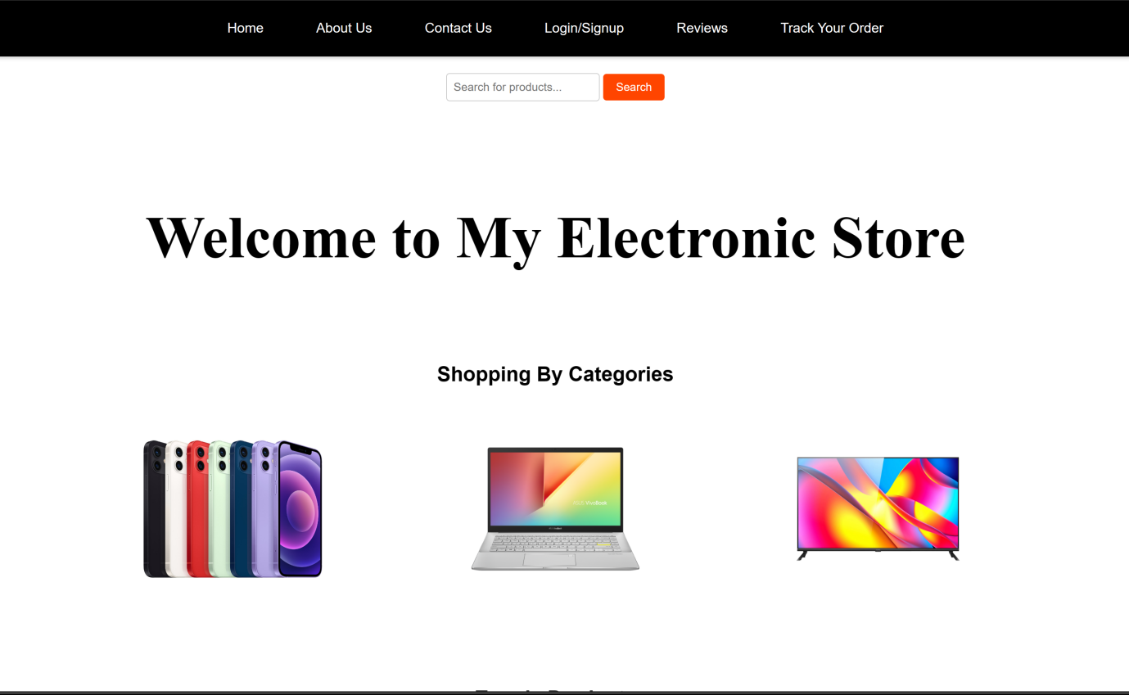Additionally, the website offers a powerful search feature. When customers initiate a search, a responsive search results page displays products matching their query, enhancing the efficiency of finding specific items. Furthermore, the project incorporates an engaging design element for the category pages, featuring product categories as oval-shaped cards. These cards visually stand out as customers hover over them, providing an attractive and interactive touch to the user experience.

Figure 1 Screenshot of Homepage

The website also highlights a section for trending products, showcasing popular items in high demand. Customers can easily explore and purchase these trending products, staying up-to-date with the latest tech innovations.

In the Electronic Store project, a wide array of products from renowned companies is available for customers to browse. These include products from brands like LG, Samsung, Apple, Oneplus, and more, ensuring customers have access to a diverse selection of high-quality electronics.

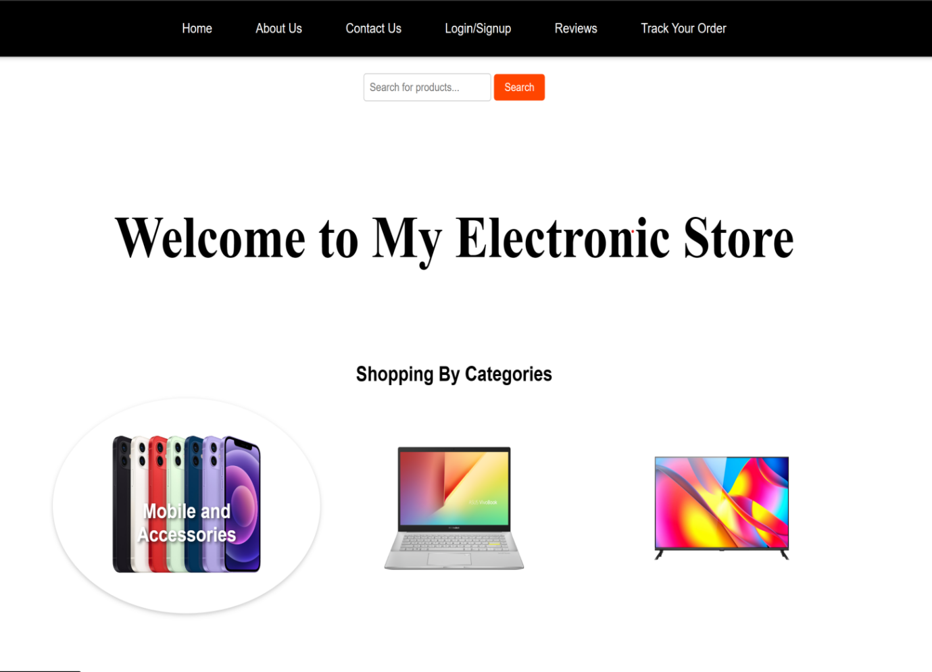Finally, the website's footer provides valuable information and resources for customers. It includes contact details for customer support, an "About Us" link for those interested in learning more about the store, a blog section, and options for returns and order tracking. This comprehensive footer enhances the user experience by offering quick access to essential information and services.

The Electronic Store project is designed to provide a seamless, engaging, and informative online shopping experience for tech-savvy customers, offering both convenience and quality in one platform. The project showcases visually captivating oval-shaped category cards with informative text descriptions that appear upon customer interaction, enhancing the user experience.

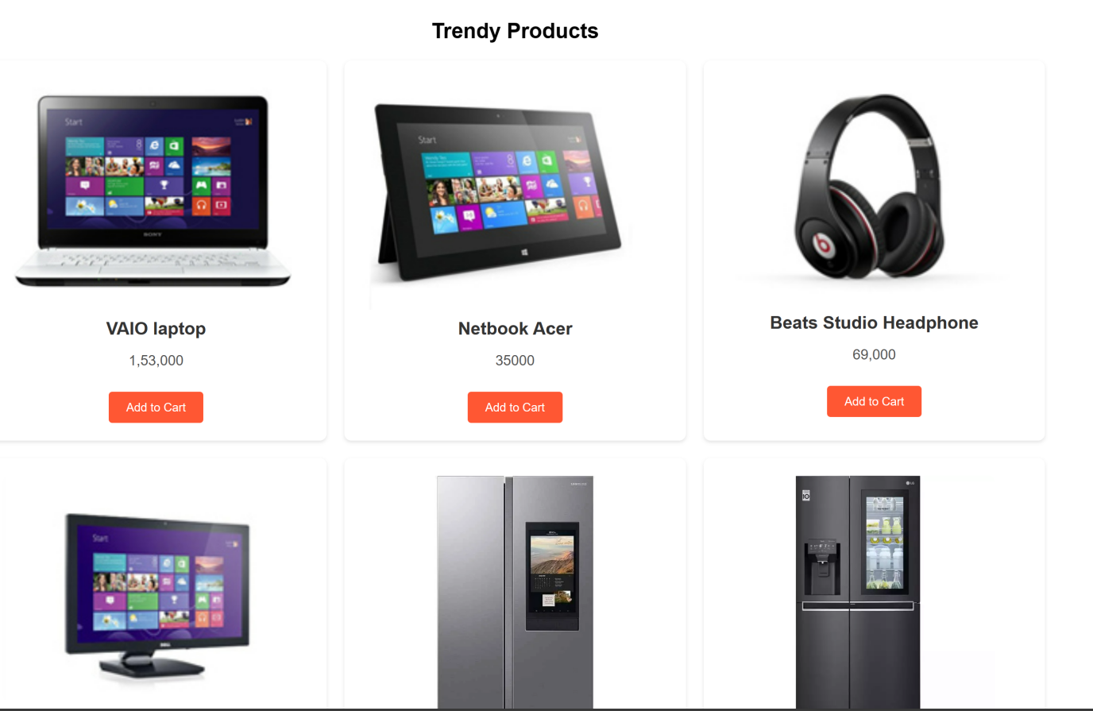

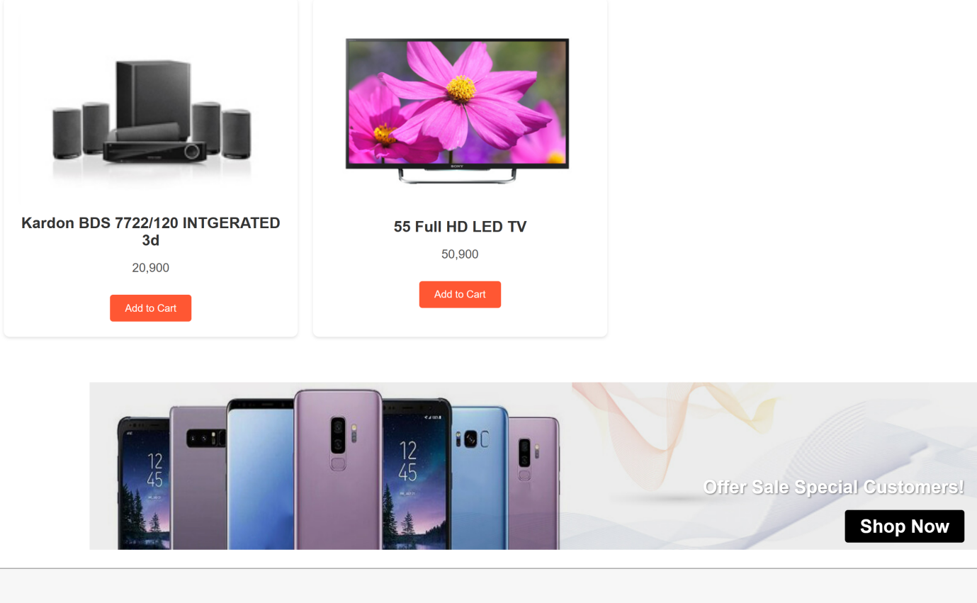

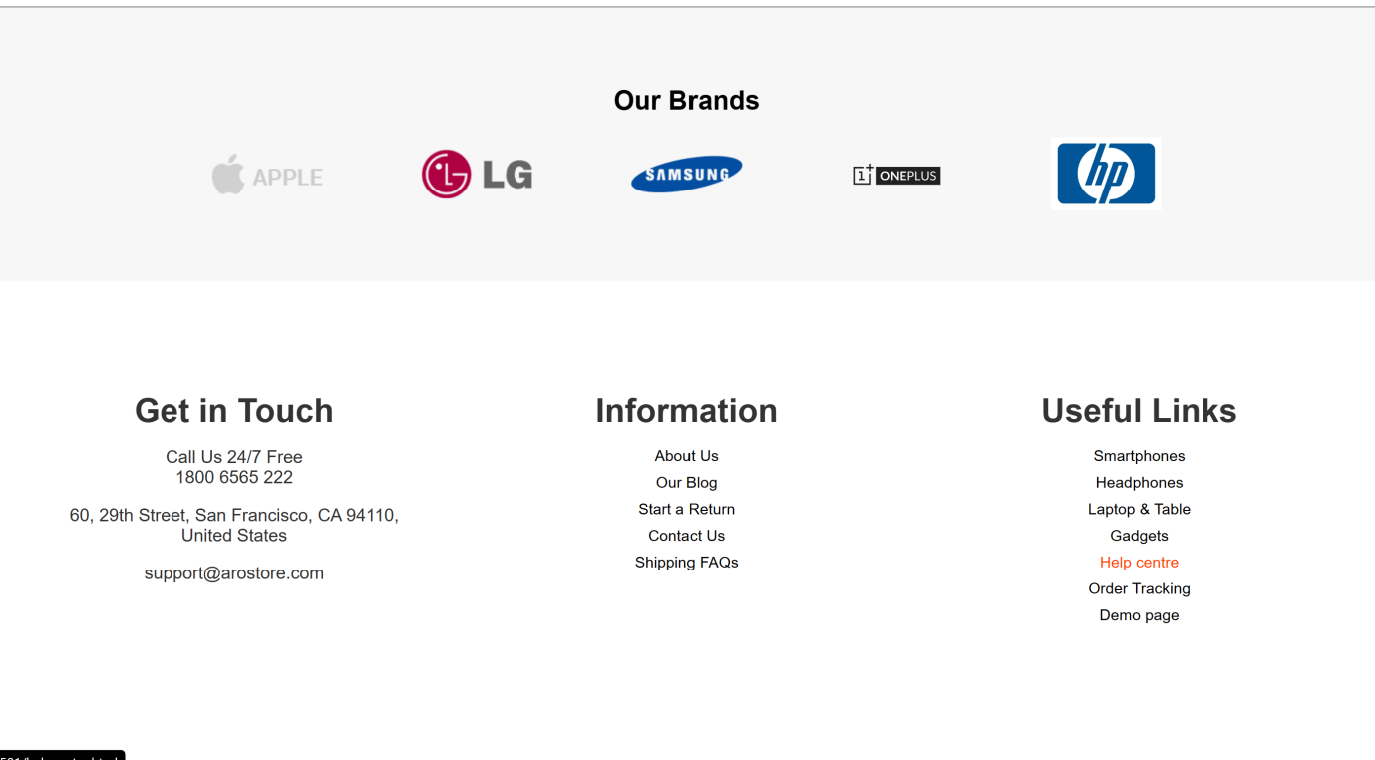

A pop-up notification efficiently confirms item additions to the cart, streamlining the shopping process.

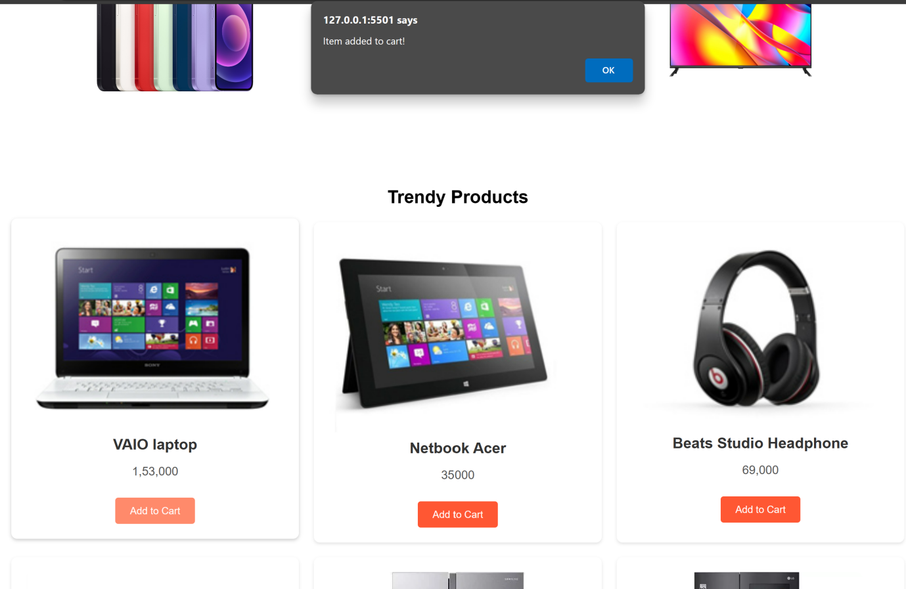

A user-friendly search feature displays a pop-up notification when customers initiate searches, enhancing the shopping experience by promptly providing results.

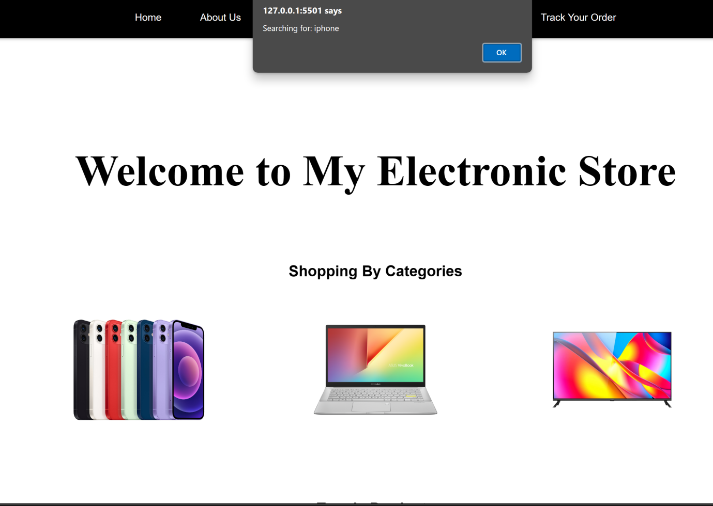

**Categories Pages**

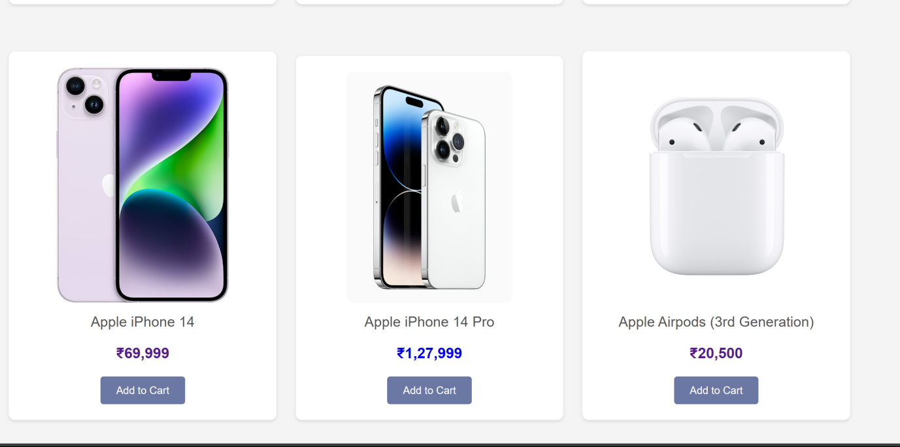**For mobile and accessories:** This is a category page for mobile and accessories, featuring a range of added products. 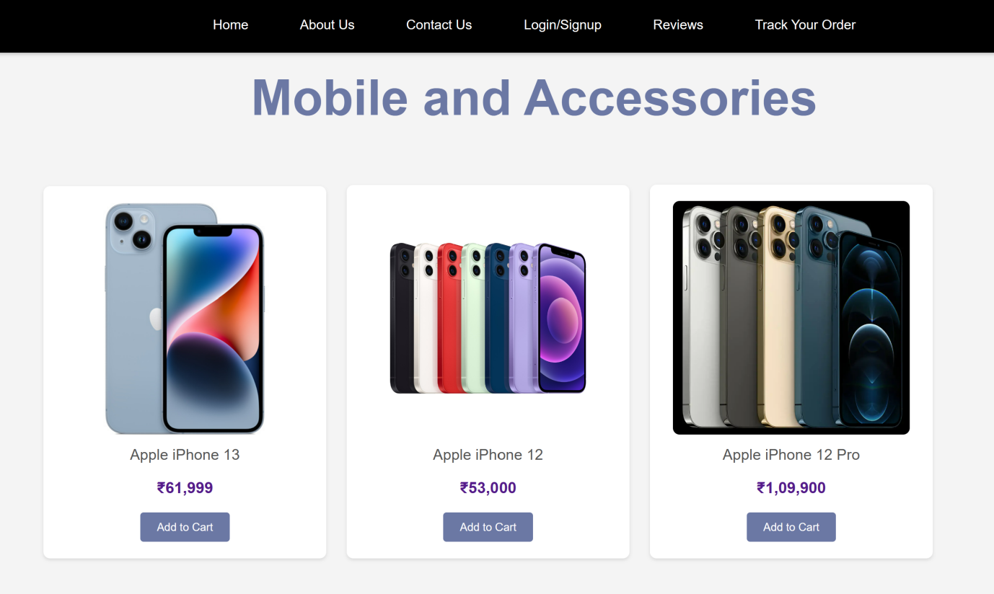

When you click on a product, it provides detailed information about that specific item, helping you make an informed decision.

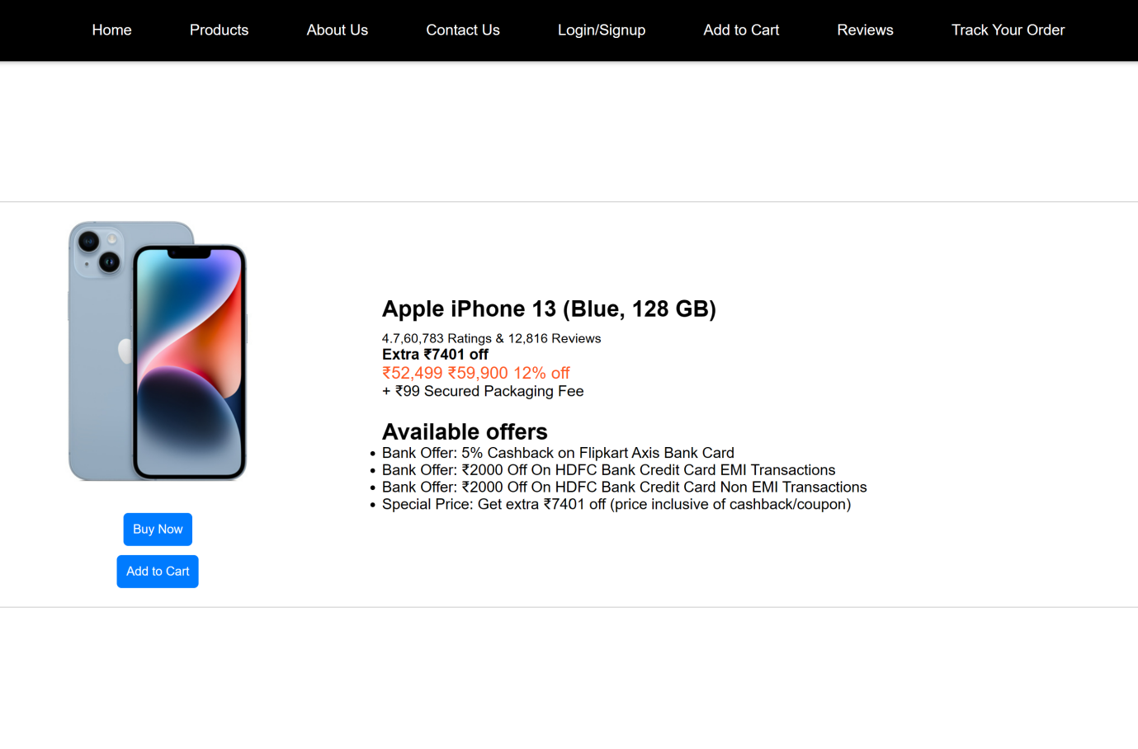

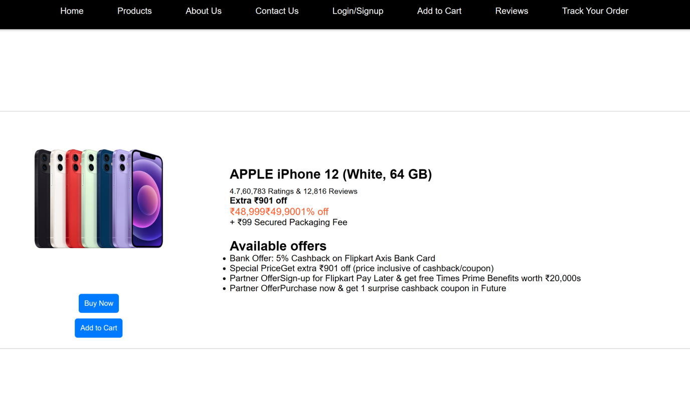

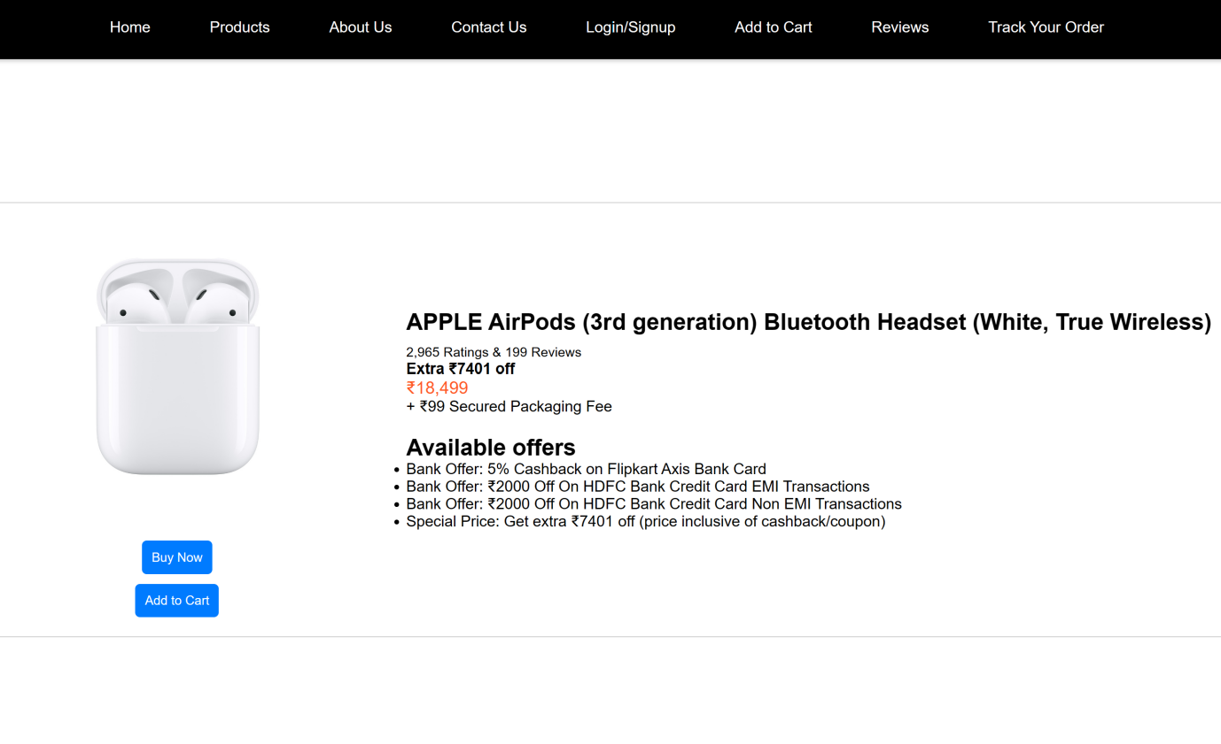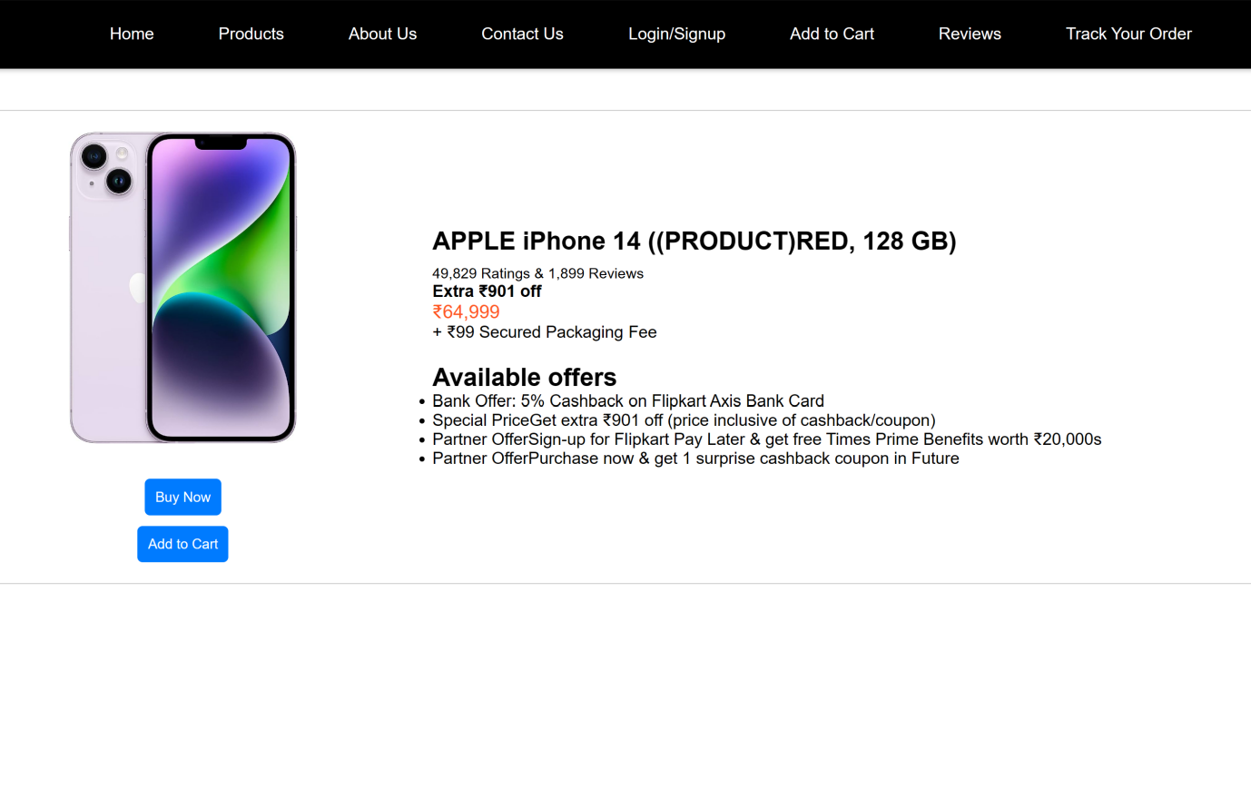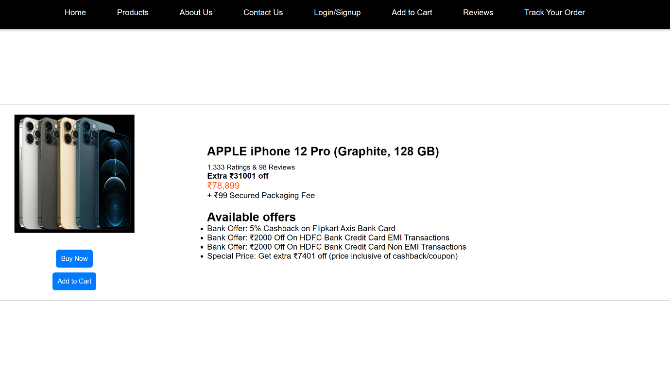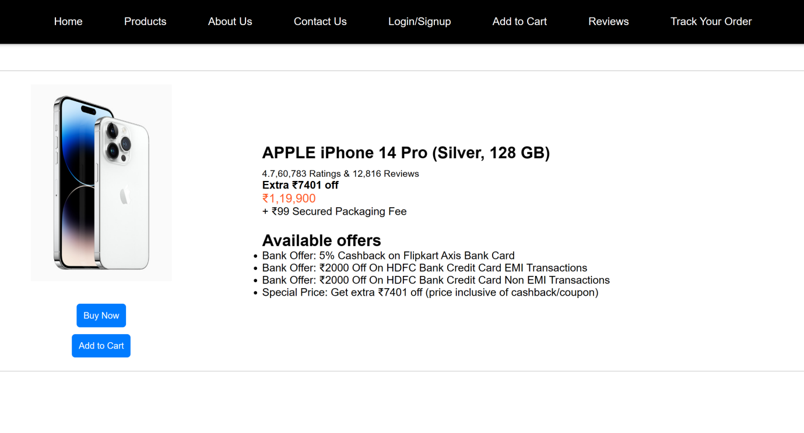

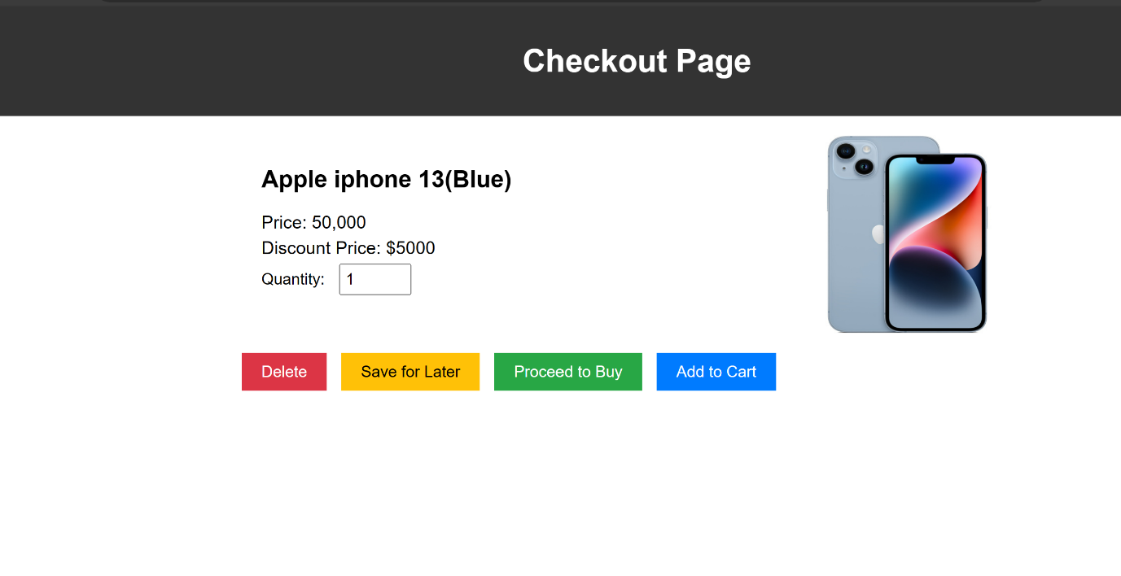Upon clicking Buy Now, you are directed to the billing page, where you have the options to Delete for Later, Save for Later, or Proceed to Buy. When you click on any of these options, a relevant pop-up appears to confirm your choice.

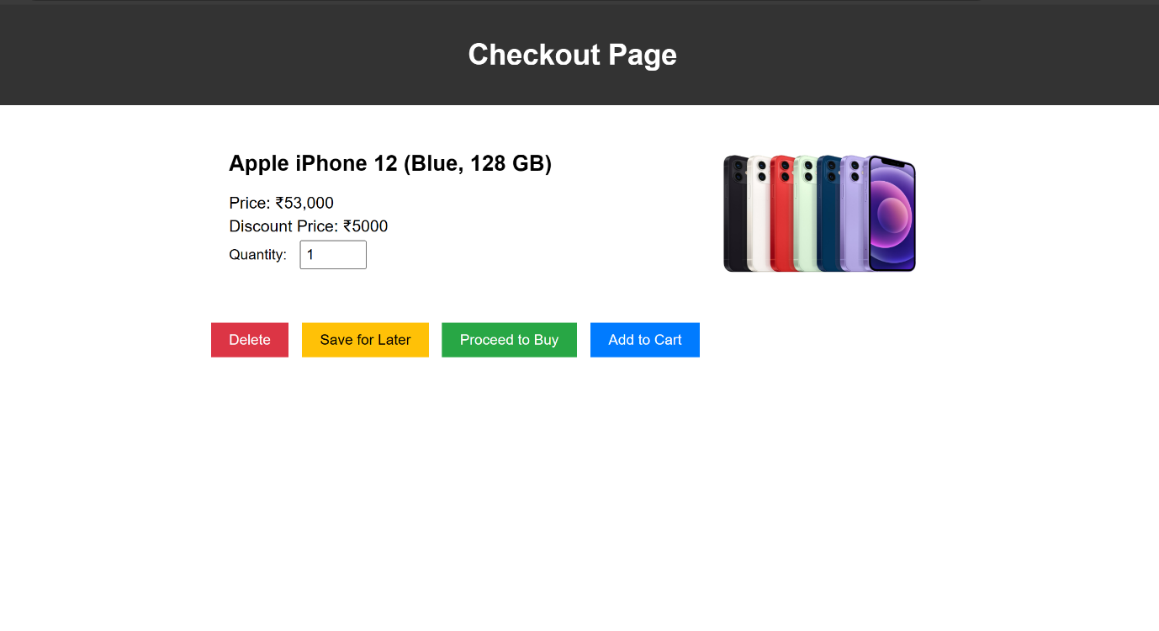

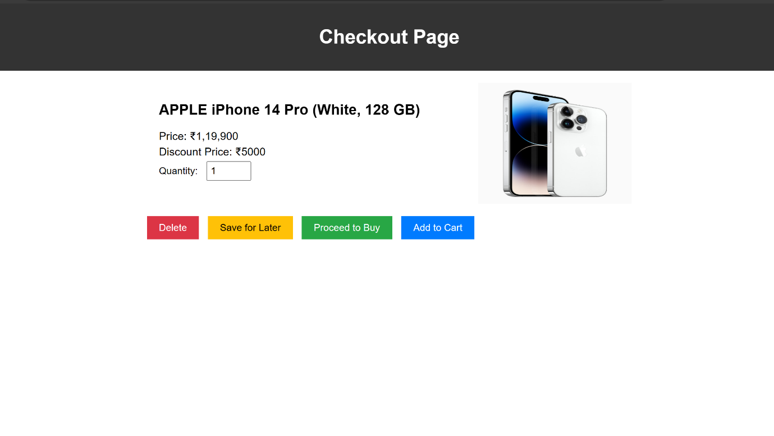

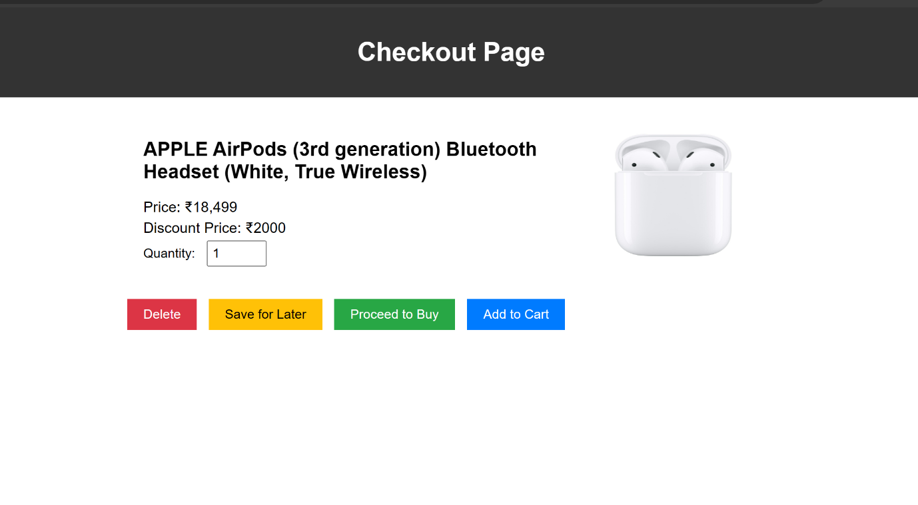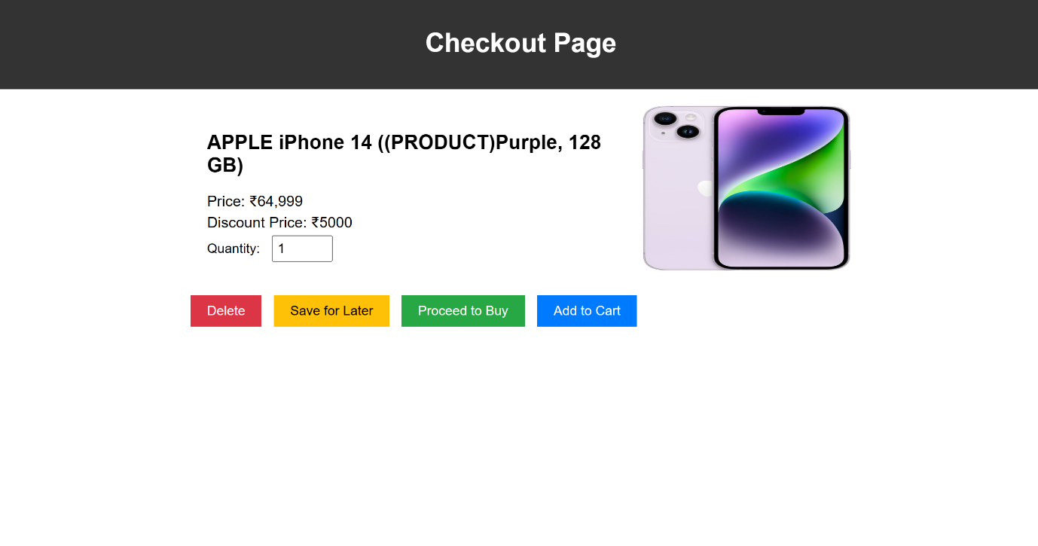

**Category page for Laptop**

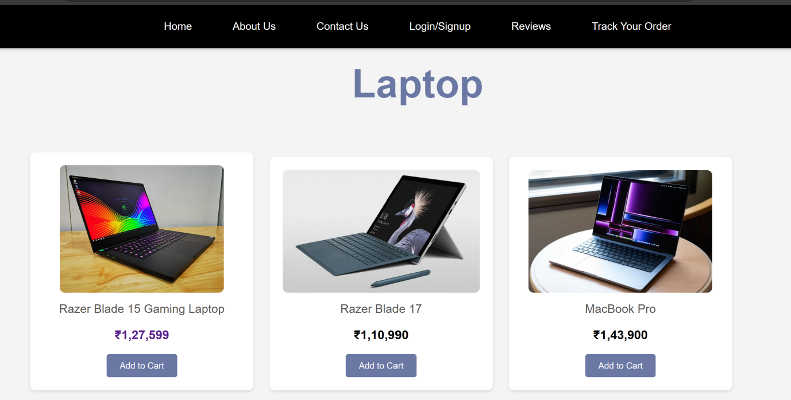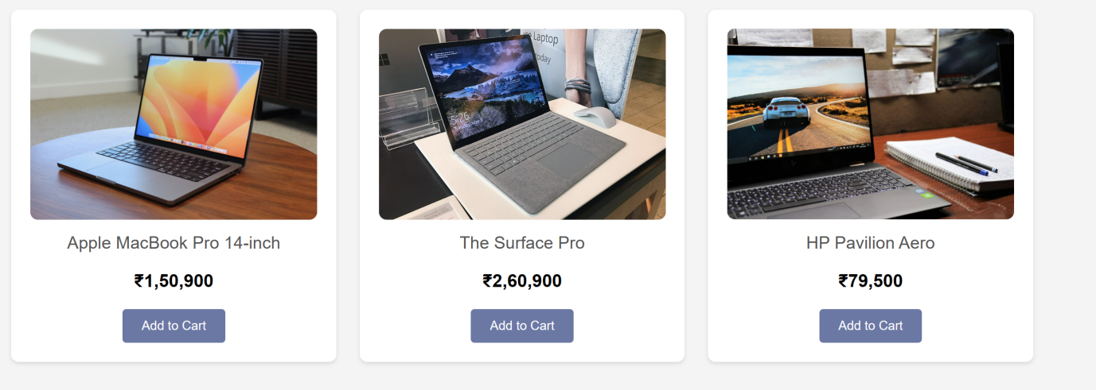

When you click on a product, it provides detailed information about that specific item, helping you make an informed decision.

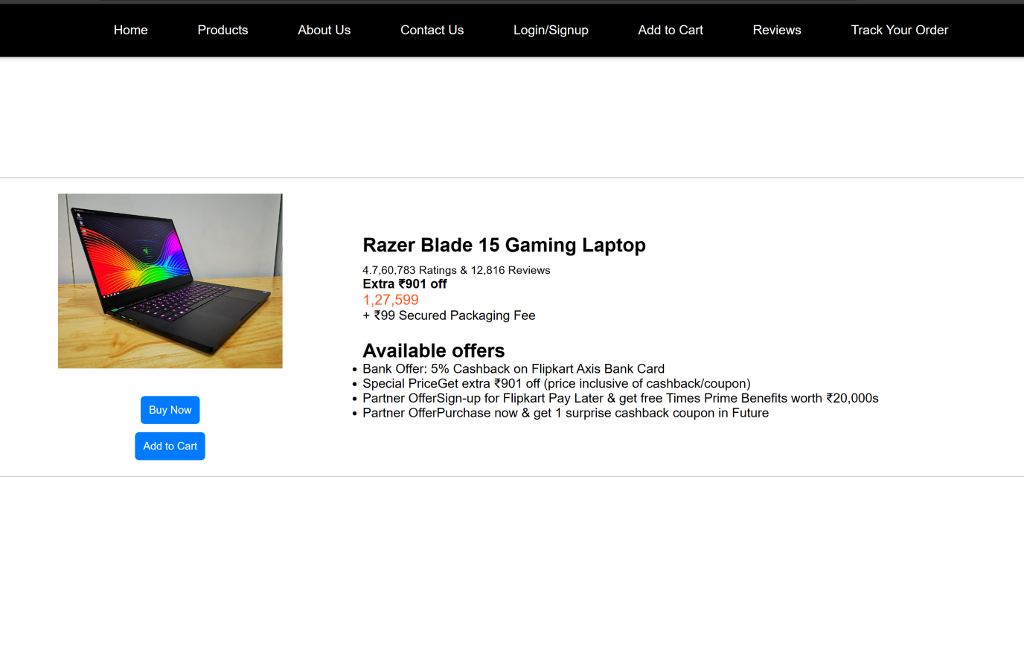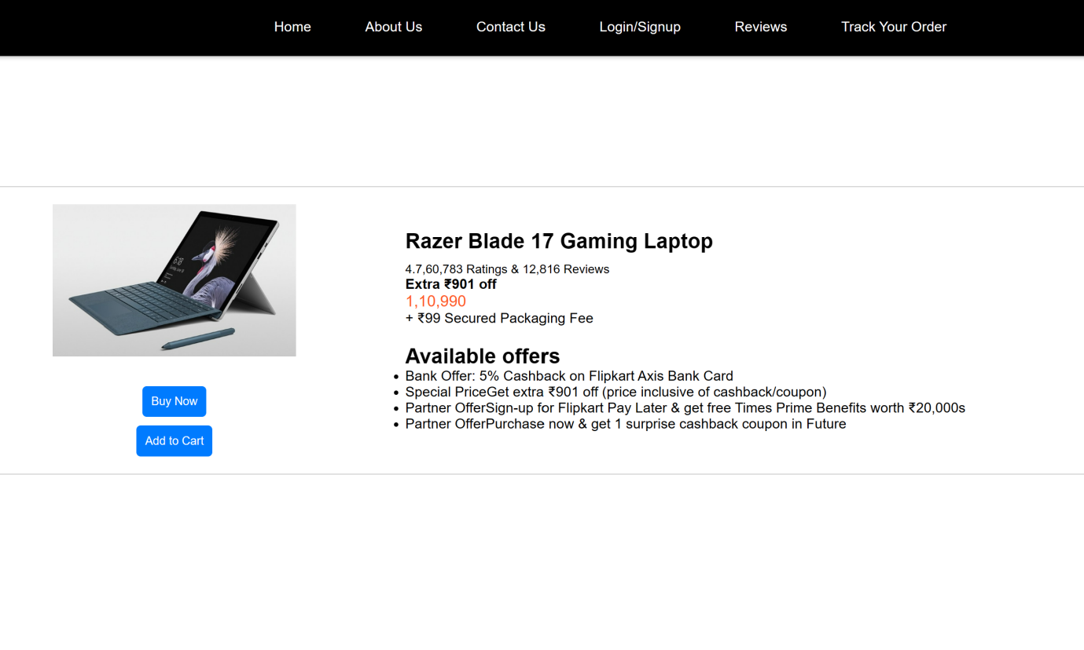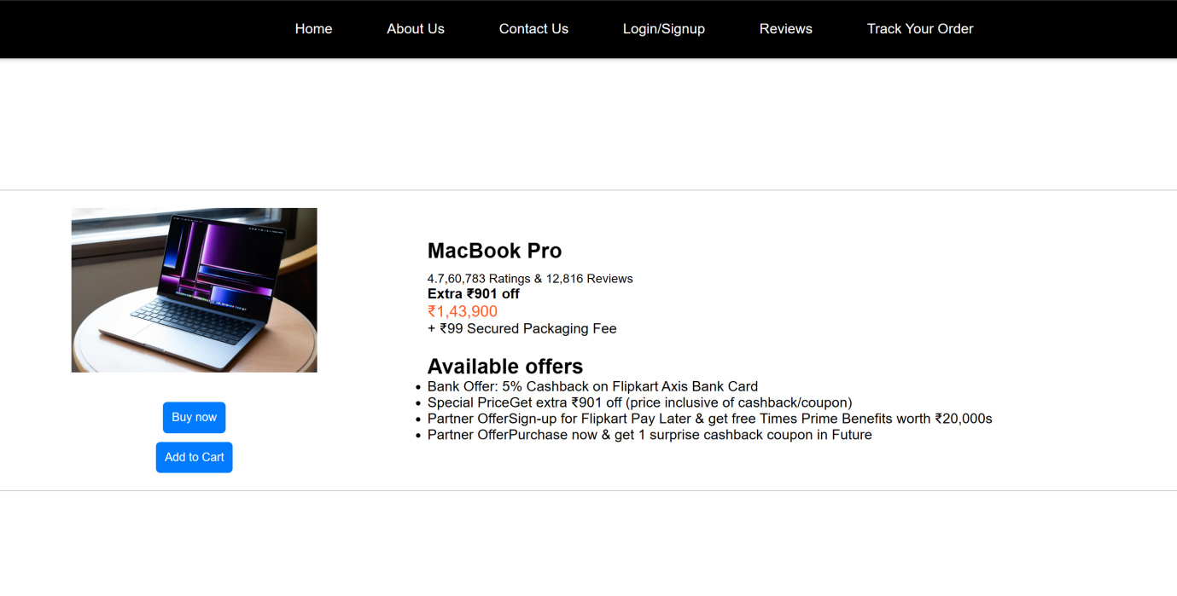Upon clicking Buy Now, you are directed to the billing page, where you have the options to Delete for Later, Save for Later, or Proceed to Buy. When you click on any of these options, a relevant pop-up appears to confirm your choice.

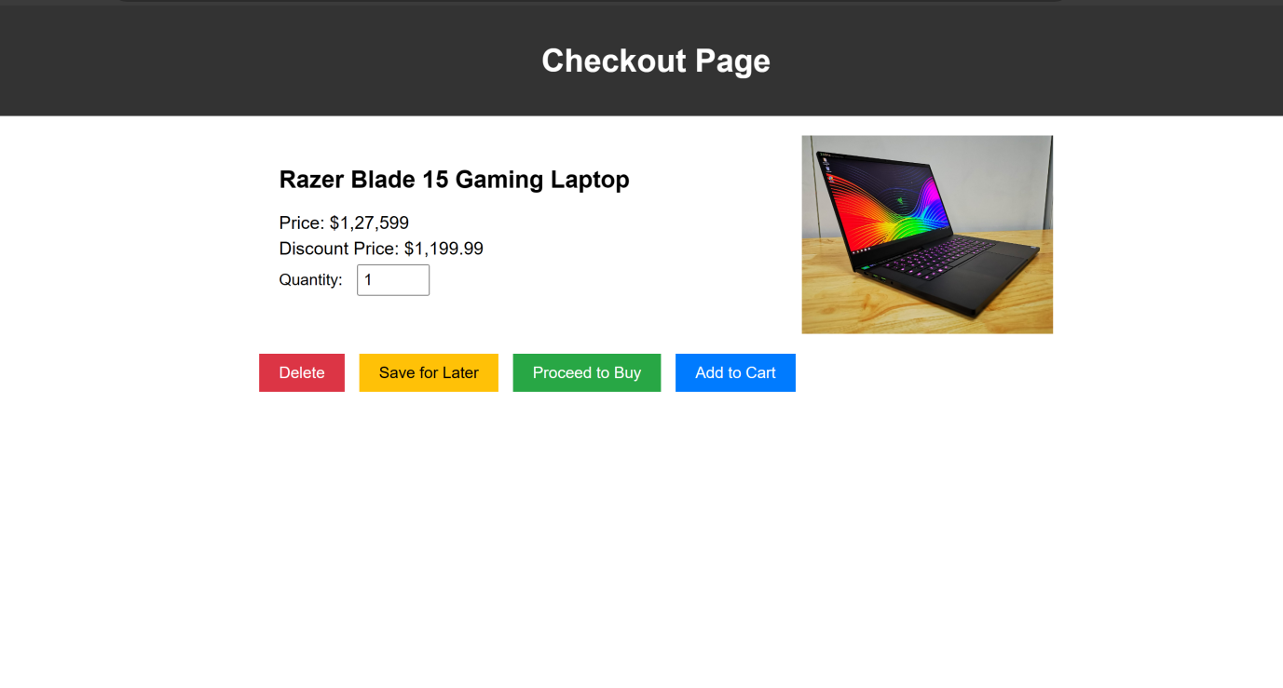

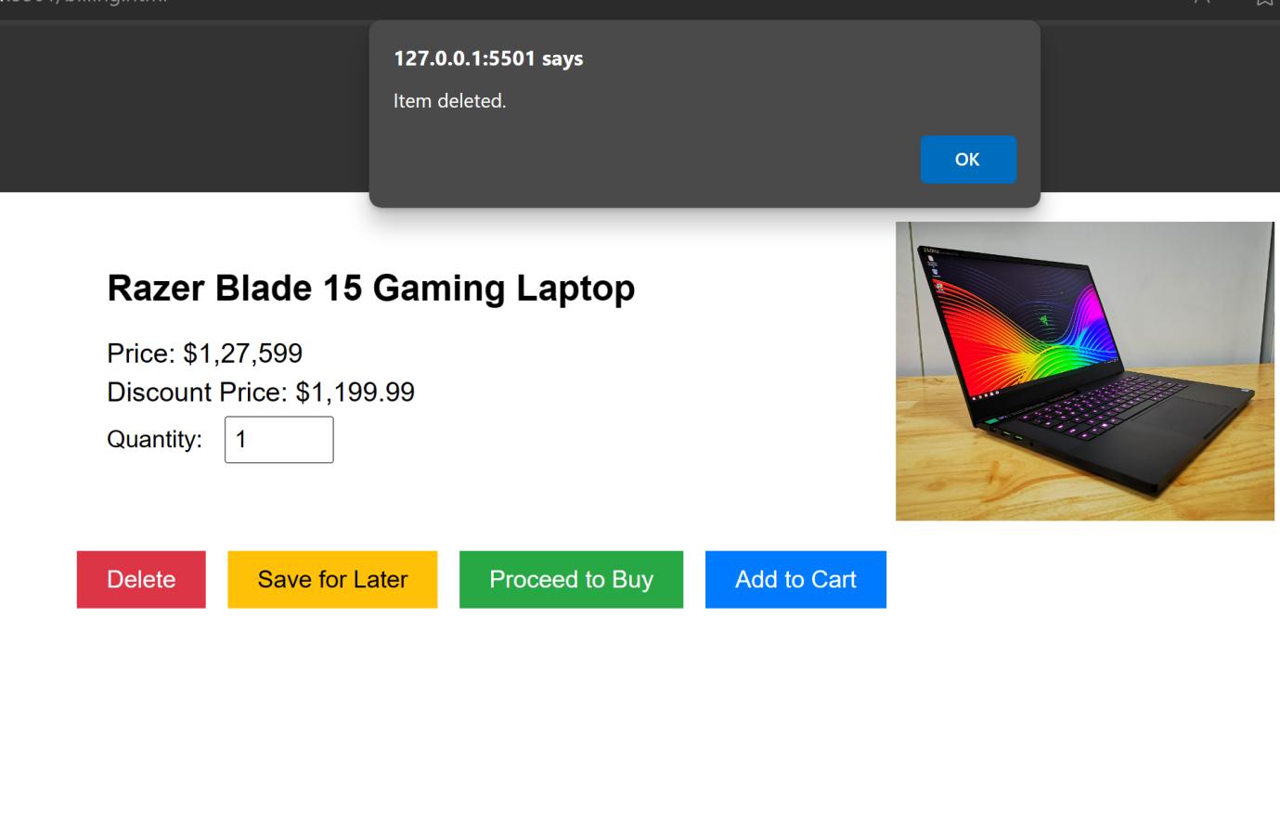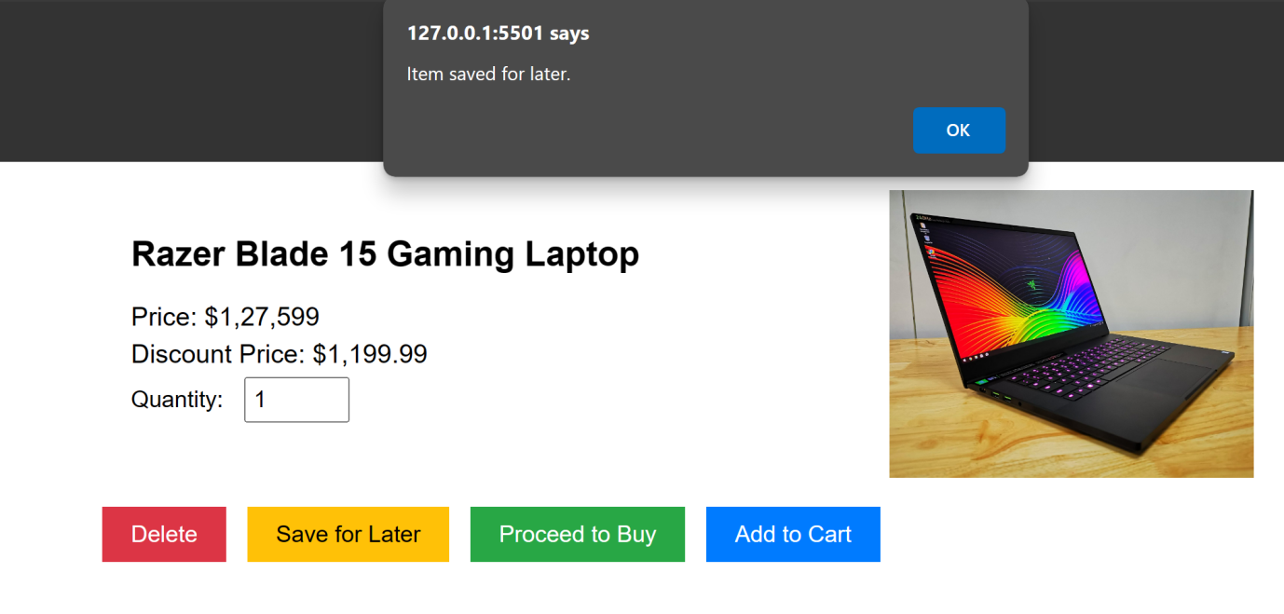

**Television page**

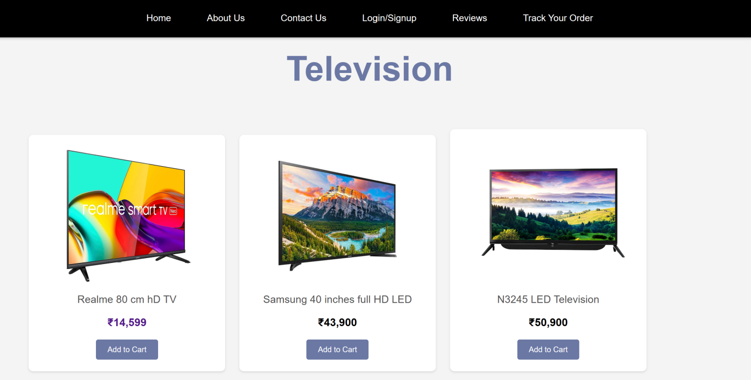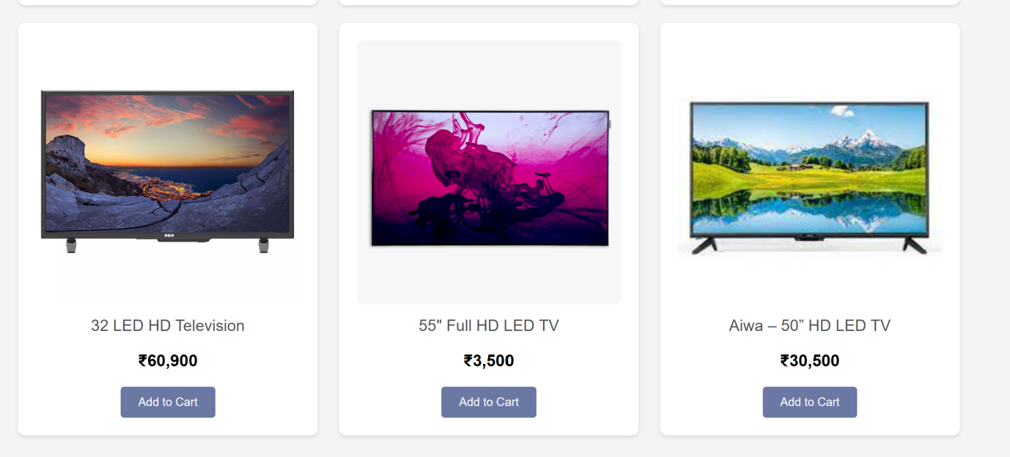

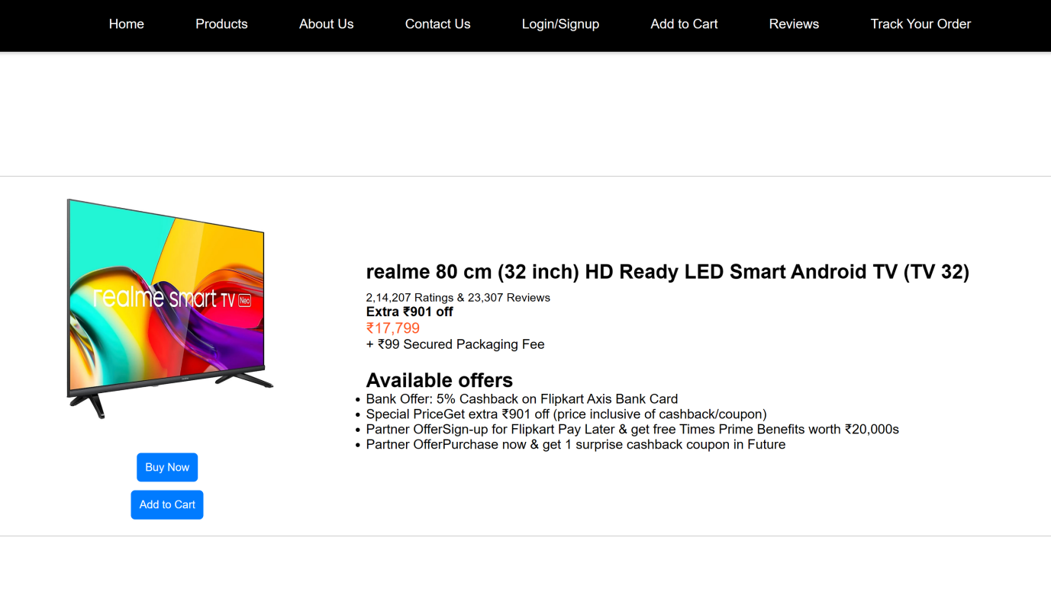

When you click on a product, it provides detailed information about that specific item, helping you make an informed decision.

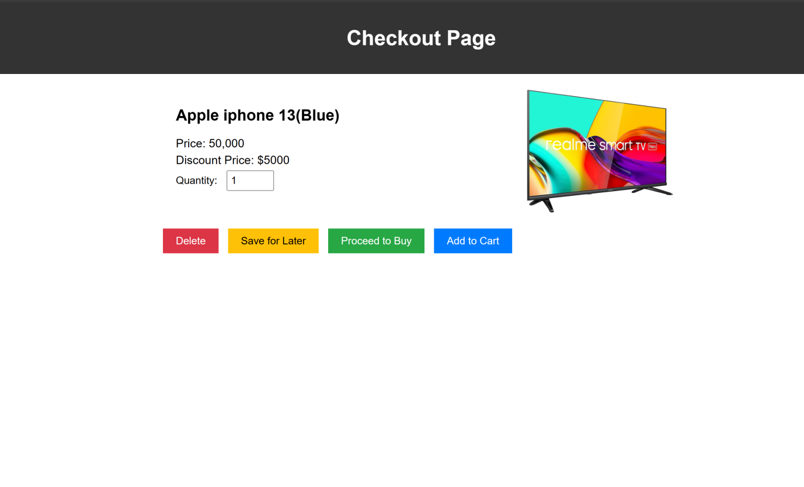

**About our store**

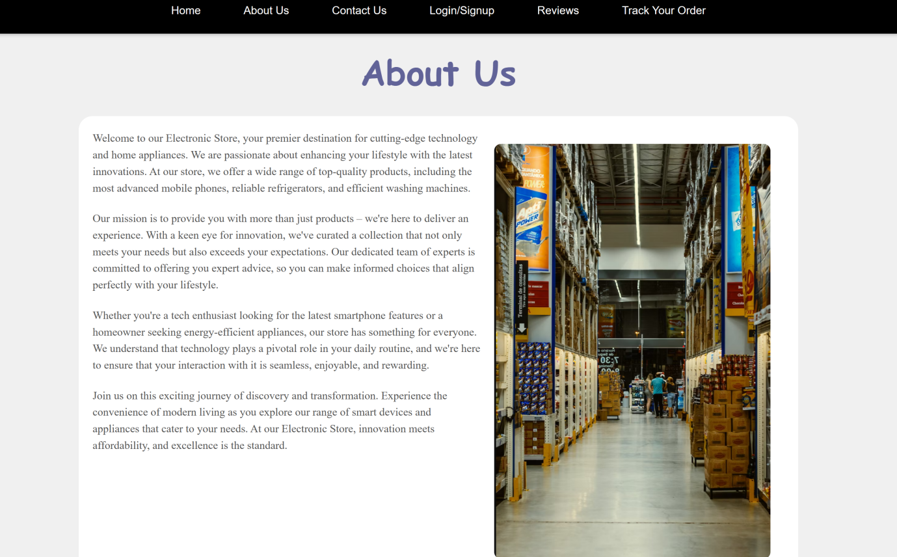The "About Us" page provides insights into our electronic store. It features an attractive image with rounded corners for a pleasing look. The text is user-friendly, making it accessible to all, regardless of technical expertise. Additionally, a top menu ensures smooth website navigation bar.

**Contact us Page**

The "Contact Us" page makes it easy to contact us. It presents a well-structured menu at the top to ensure easy navigation throughout the website.

The primary section of the page is thoughtfully divided into two parts. The initial section labelled "Get in Touch," offers a user-friendly form for visitors to share their queries, comments, or feedback. The form includes fields for name, email, and message, enabling easy submission of inquiries. A Submit button allows users to send their messages swiftly.

To enhance user experience, JavaScript is employed for form validation. If a user fails to fill in any required fields, a helpful prompt appears, ensuring that all necessary information is provided before submission. This proactive validation minimizes errors and streamlines the communication process.

In the subsequent section, "Contact Information," we provide alternative contact methods for our visitors. This includes our email address, phone number, and physical address. These varied contact details ensure that visitors can choose the communication approach that suits them best

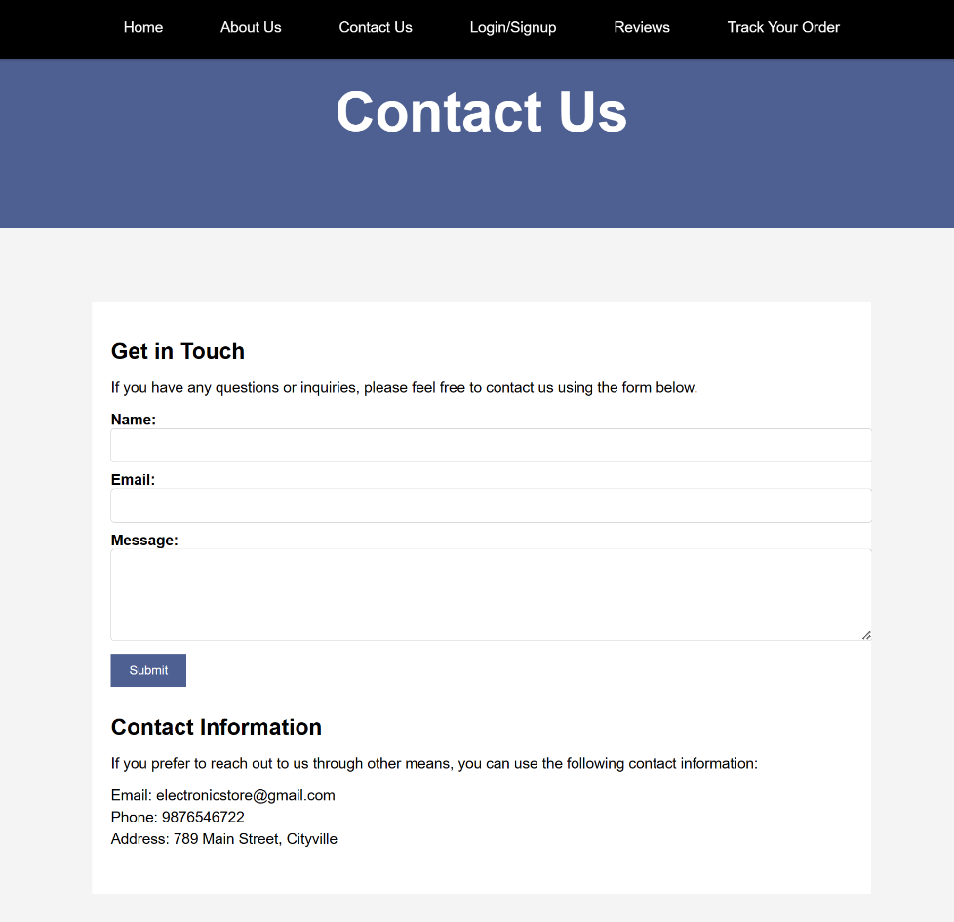

**Sign up Page**

Crafting the sign-up page for our electronic store has proven to be essential in enhancing the overall shopping experience for our valued customers. The page architecture is meticulously designed, featuring an easily navigable menu that provides quick access to various store sections. Central to this page is the well-structured sign-up form, where individuals can input their personal information, including full names email addresses, choosing passwords, and password confirmations. In our commitment to data integrity, we've integrated a comprehensive validation process that triggers informative pop-up alerts in cases where critical details are omitted, or password entries do not align. Upon successful form submission, a reassuring confirmation pop-up awaits users. This meticulously designed sign-up page streamlines the registration process and fosters trust and engagement with our electronic store, setting the stage for a seamless shopping journey.

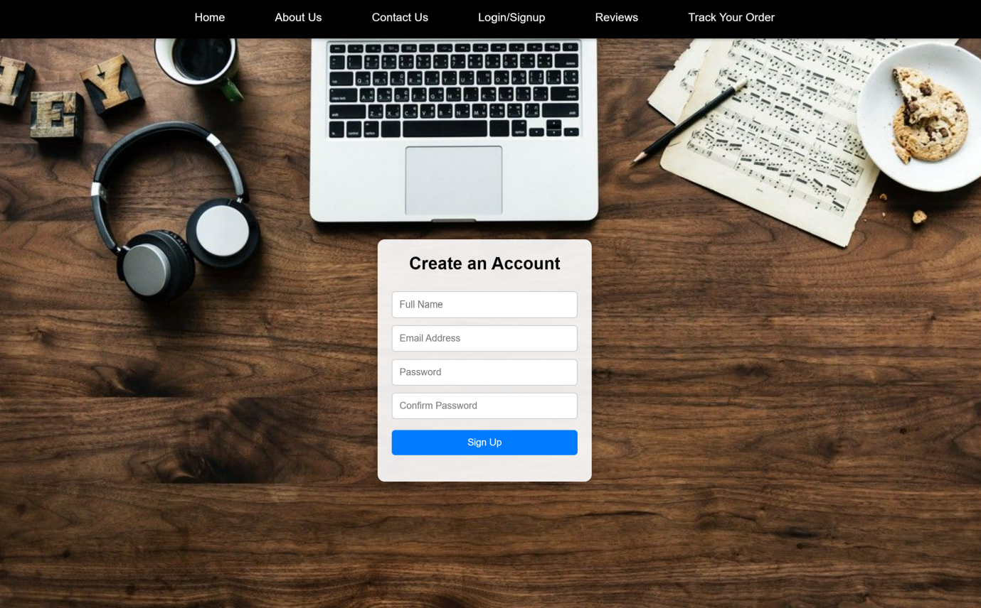

**Sign up Page**

When the entered passwords don't match, a pop-up appears with the message Passwords do not match.

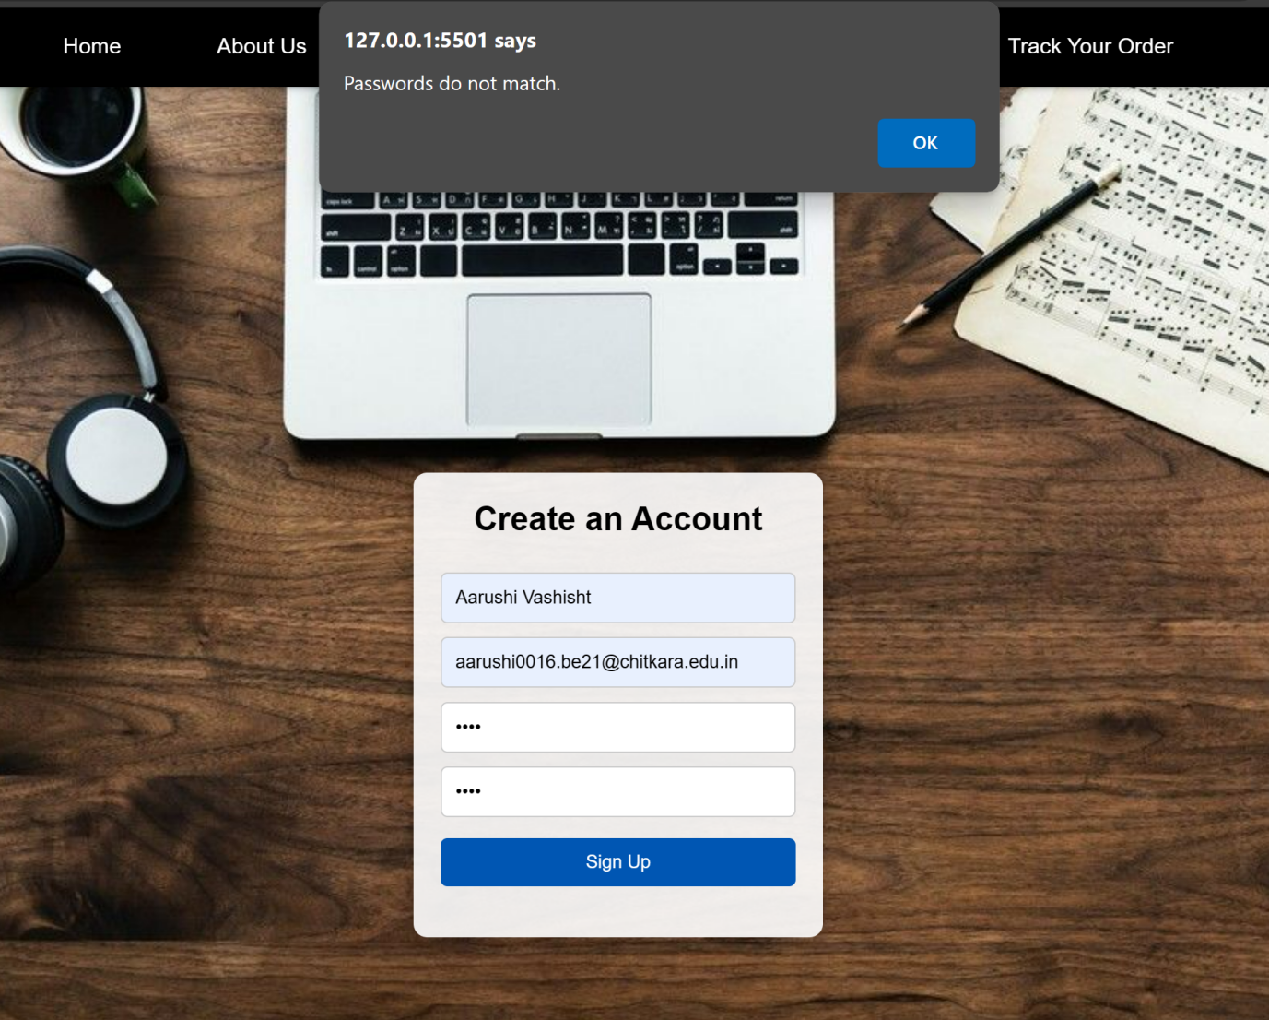

**Review page**

On the "Reviews" page, you can easily submit your thoughts and feedback through a user-friendly review form. The form is designed with simplicity, ensuring a hassle-free experience when sharing your opinions.

User-generated reviews are presented in an organized manner, each enclosed in a neatly designed container. This consistent design not only makes the reviews visually appealing but also adds to the overall readability.

The implementation of JavaScript to store and retrieve reviews locally not only ensures that users' feedback is preserved but also allows for seamless browsing without the need for complicated account setups or logins.

In summary, the "Reviews" page is a user-centeric space dedicated to fostering feedback and interaction. The aim is to provide visitors with an effective platform to voice their thoughts and, in turn, enhance the overall website experience.

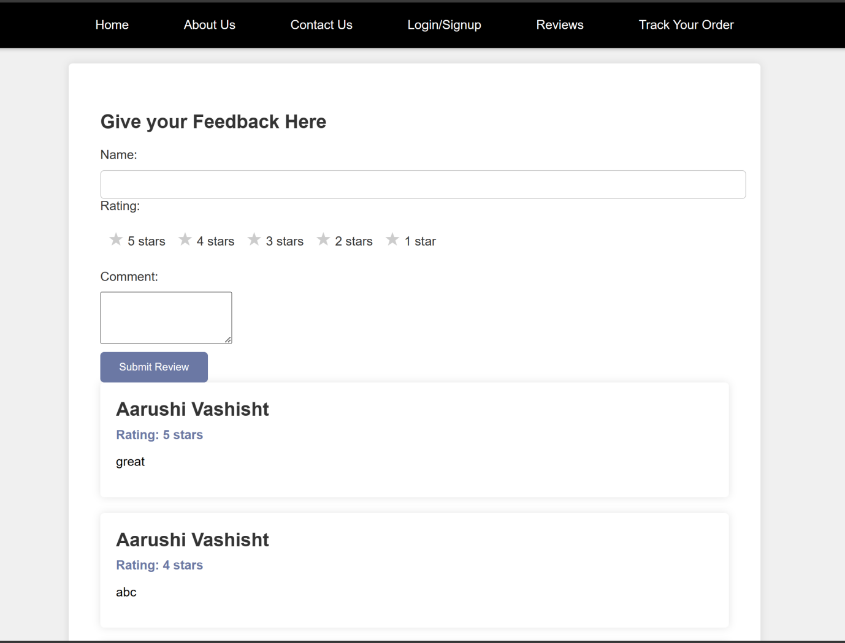

**Track Your order Page**

Track Your Order page provides a user-friendly and straightforward platform for monitoring the status of your orders. You can access real-time updates on your purchases by simply entering your Order ID and billing email. The page also offers a comprehensive footer with valuable resources. In the Get in Touch section, you can find contact information for 24/7 support and email assistance. The Information segment offers insights into About Us, Our Blog, Start a Return, and Contact Us, along with answers to frequently asked questions in Shipping FAQs.

Additionally, the Useful Links section lets you explore various product categories like Smartphones,Headphones,Laptops & Tablet, and Gadgets while efficiently managing your account and tracking orders. The Electronic Store prioritizes your convenience and is committed to delivering a seamless shopping experience for all your electronic needs. 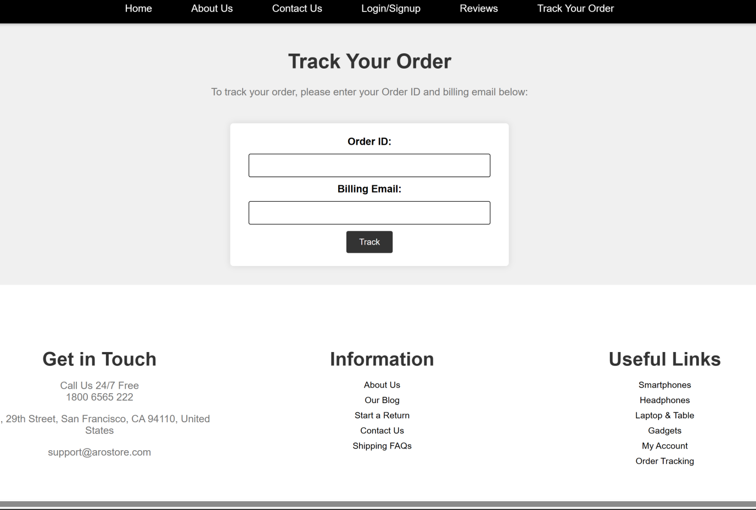

**Demo Page**

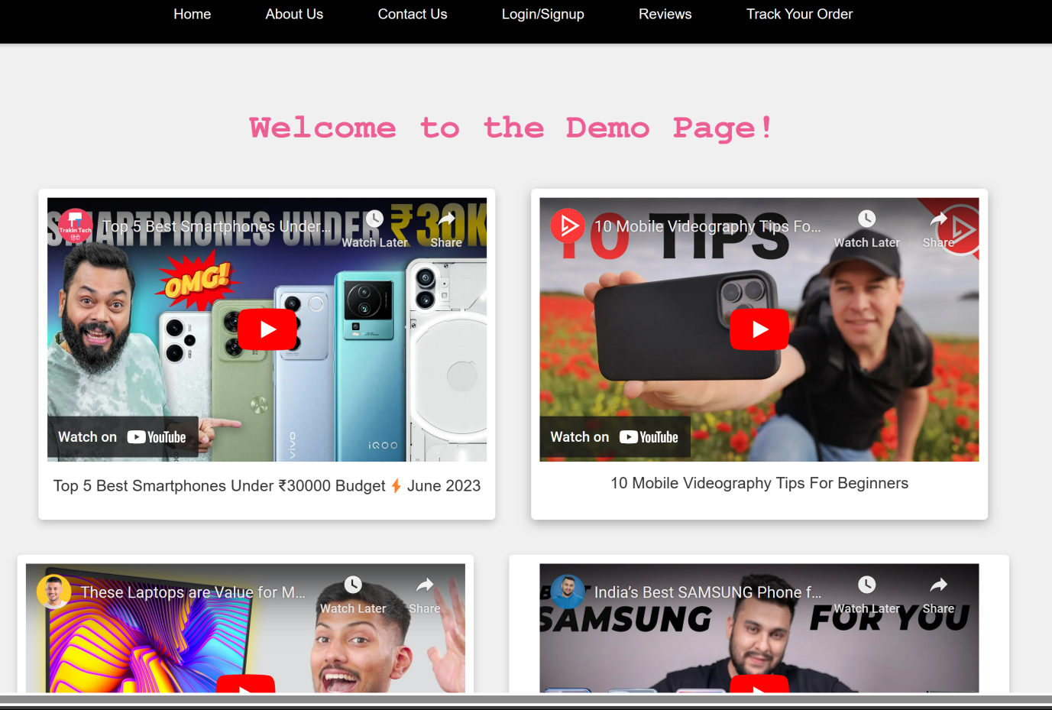This webpage showcases a visually appealing and user-friendly design. It maintains a consistent colour palette that complements the content. The typewriter animation adds a welcoming touch, engaging visitors upon arrival. The video containers are aesthetically pleasing and offer a comfortable viewing experience, enhancing the overall presentation. These YouTube videos exemplify how video integration is seamlessly achieved and encourages sharing. Each video is accompanied by concise descriptions, facilitating user choices and interactions. The thoughtful arrangement of elements within the design ensures a clear and intuitive user experience. It caters to the preferences of a contemporary online audience, effectively balancing aesthetics and functionality.

**Help Centre page**

The Help Center webpage provides a valuable resource for users to resolve various issues related to online shopping quickly. It features a clear and organized design, ensuring ease of navigation. The Frequently Asked Questions (FAQ) section offers solutions to common queries, such as creating an account and accepting payment methods.

In particular, the "About Help Center" section elaborates on the purpose of this page. It emphasizes comprehensive support for order tracking, delivery date adjustments, and returns. Users can easily access a wide range of services, payments, and shopping information. Filters on the left side further facilitate a hassle-free experience, and users can seek assistance from the Help Center support team. This support swiftly resolves issues, providing a positive and enjoyable shopping experience.

The webpage also includes a "Contact Us" section where users can submit their inquiries for added convenience. Once the contact form is filled out, an alert will notify users that their message has been sent successfully.

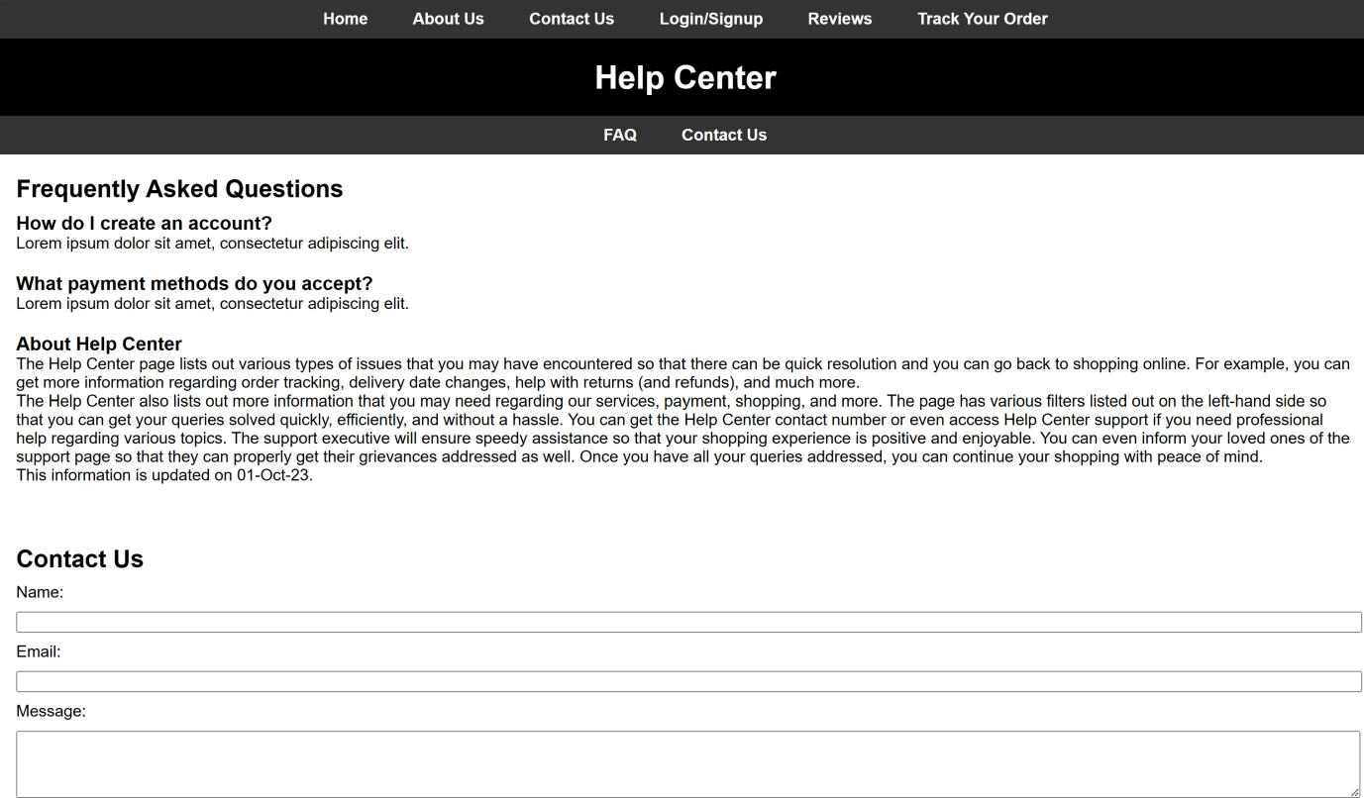



Upon completing the contact form, a pop-up alert confirms, "Your message has been sent. Thank you!"

